Brightness

📘 Definition
# Source: AI Source: Provided by: [Data Path: Persons Table -> ID Column: 1, Name_En Column: Motasem Essam] -> From: [ChatGPT] on [5/2/2026]
Brightness is how light or dark a color or image appears. It describes the amount of light coming from or reflected by an object or a screen.

💡 How brightness works
# Source: AI Source: Provided by: [Data Path: Persons Table -> ID Column: 1, Name_En Column: Motasem Essam] -> From: [ChatGPT] on [5/2/2026]
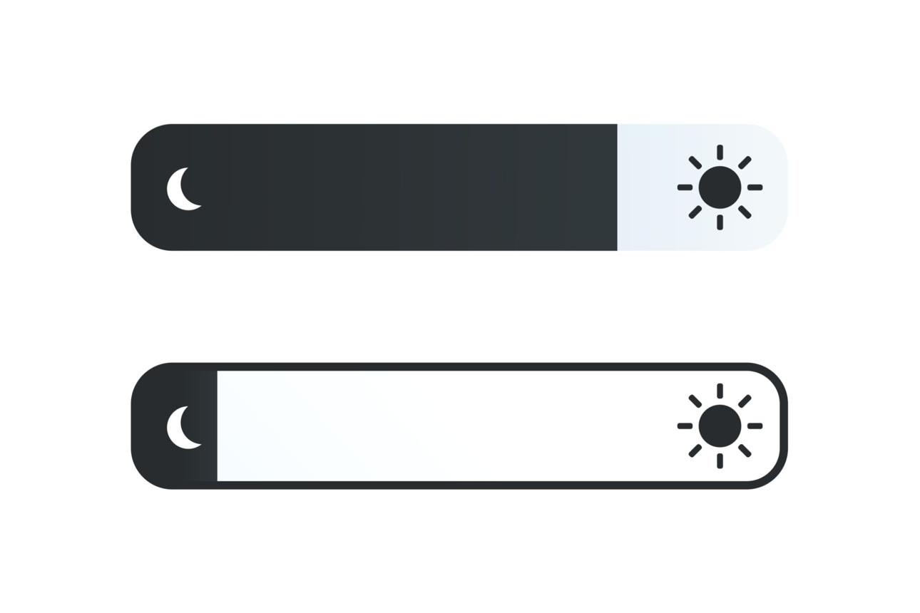
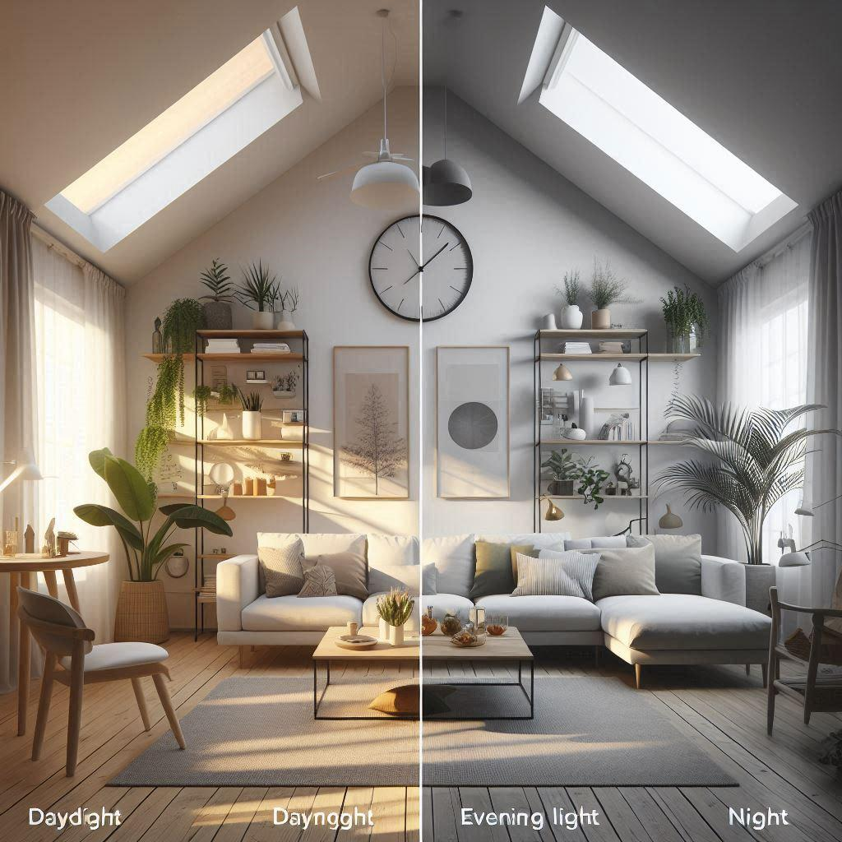
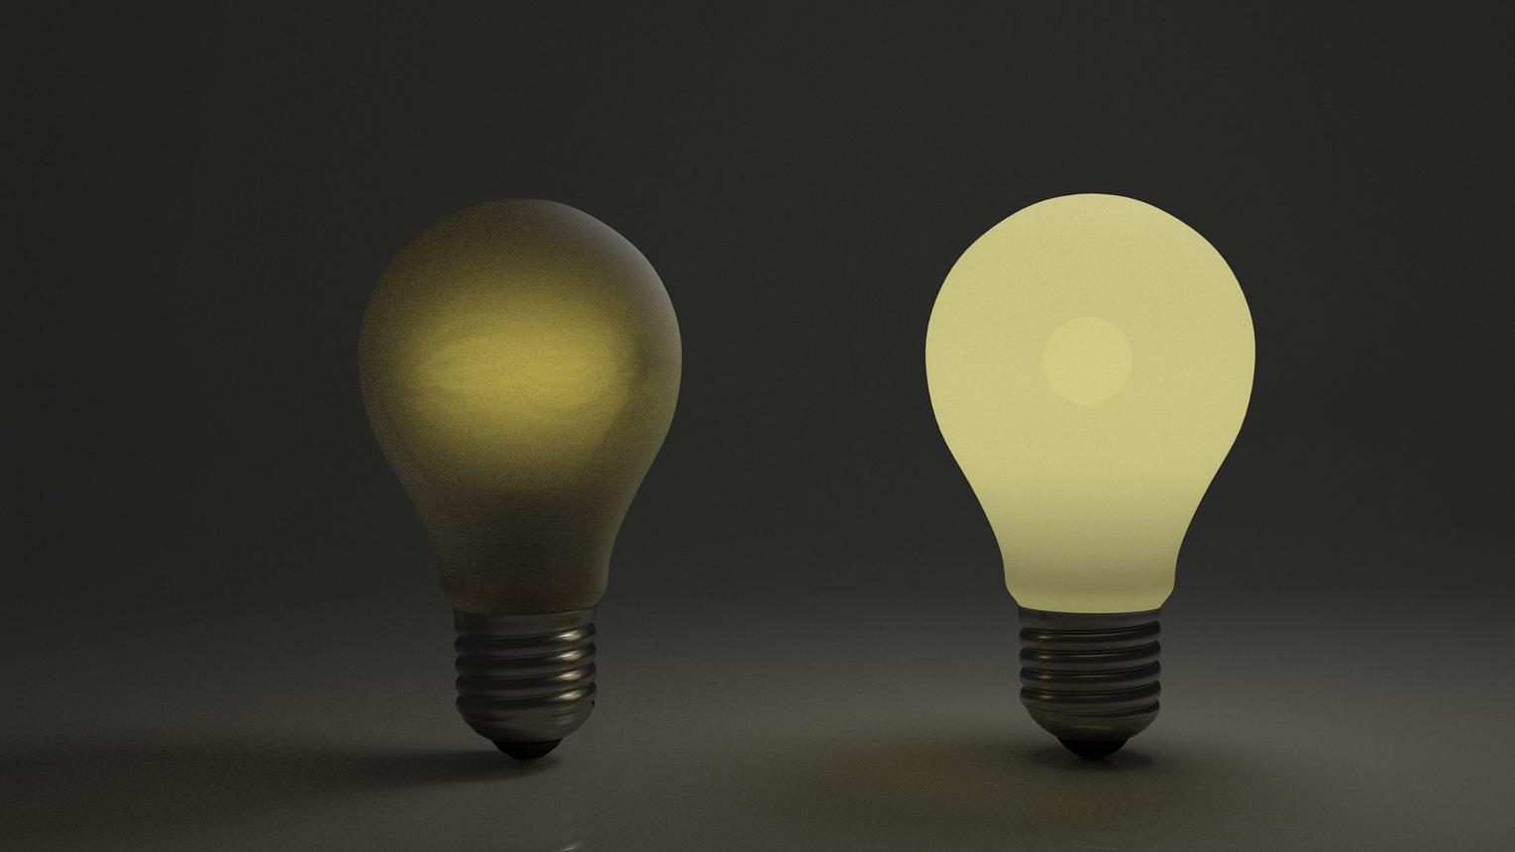
- More light → brighter image
- Less light → darker image
In simple terms:
- Brightness = how much “light” you see
- Darkness = low brightness

🧠 Simple example
# Source: AI Source: Provided by: [Data Path: Persons Table -> ID Column: 1, Name_En Column: Motasem Essam] -> From: [ChatGPT] on [5/2/2026]
Think of a lamp:
- 🔆 High brightness → lamp is very strong and the room is bright
- 🔅 Low brightness → lamp is weak and the room looks dark
On a phone or computer screen, increasing brightness makes everything easier to see in daylight.

🎨 Brightness in graphics
# Source: AI Source: Provided by: [Data Path: Persons Table -> ID Column: 1, Name_En Column: Motasem Essam] -> From: [ChatGPT] on [5/2/2026]
In computer graphics and color models:
- In HSV, brightness is called Value (V)
- In HSL, brightness is called Lightness (L)
It controls:
- How vivid an object looks
- How realistic lighting appears
- How shadows and highlights are seen

🎮 Where brightness is used
# Source: AI Source: Provided by: [Data Path: Persons Table -> ID Column: 1, Name_En Column: Motasem Essam] -> From: [ChatGPT] on [5/2/2026]
- 📱 Phone and screen settings
- 🎮 Video game lighting
- 🎬 Movies and animation
- 🎨 Photo editing tools

🚀 In short:
# Source: AI Source: Provided by: [Data Path: Persons Table -> ID Column: 1, Name_En Column: Motasem Essam] -> From: [ChatGPT] on [5/2/2026]
Brightness = the level of light in an image or color that makes it look lighter or darker.

